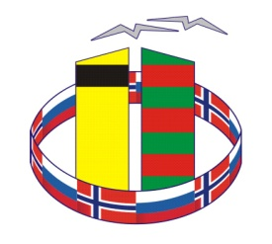
Application form for participants of
VI Russian-Norwegian Days of Cross-Border Cooperation

Name of organization _____________________________________________________
Address/telephone number/e-mail _____________________________________________________________
List of participants from organization:
1. ______________________ (name/surname, occupation) _tel. __________ e-mail: _____________
2. ______________________ (name/surname, occupation) _tel. __________ e-mail: _____________
Please, confirm your participation in the program’s events:
27 October 2016  (Nikel, culture center “Voshod”) |  | 28 October 2016  (Nikel)
12:00 – 17:00  Official opening and plenary session of the VI Russian-Norwegian Days of Cross-Border Cooperation | 17.30 - 18.30  B2B meetings on tourism sphere cooperation | 10.00 – 13.00  Presentation of sport possibilities of the Pechenga district – programme of sporting competitions | 13.00 - 15.00  Opening of the Russian-Norwegian exhibition of children's creativity as part the project "neighbors and friends" | 14.00-15.30  Excursion to Trifonov-Pechenga Monastery
_____Yes / ____No | _____Yes / ____No | _____Yes / ____No | _____Yes / ____No | _____Yes / ____No

Booking of accommodation and transport is provided for participants:
We kindly ask you to mark the required transport reservation in the table below
Date and departure time | Itinerary |  | Reservation mark
27.10.2016, 8:00 | Murmansk, Leningradskaya Str. | Nikel (cultural centre «Voskhod»)
27.10.2016, 19:00 | Nikel (cultural centre «Voskhod») | Murmansk
28.10.2016, 7:30 | Murmansk | Nikel
28.10.2016, 16:00 | Nikel | Murmansk

Accommodation reservation during the event days, if necessary (27.10.2016 – 28.10.2016):
Stay in hotel «Pechenga» (name/surname) | Room category *
1.
2.
*- we will inform you about the price for accommodation additionally
The program can be modified.

Extra requests from the participant:

Please, send the filled-in applications to e-mail: rn.cooperation@astavia.com
Project Coordinator – Igor Schipin 8-911-339-75-37.

